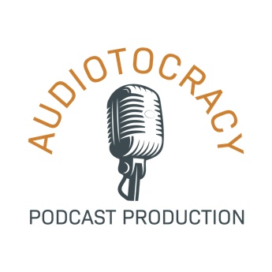

Hi, this is Shannon Perry, founder of Audiotocracy Podcast Production.

Hosting a podcast can be great for business — you can not only set yourself up as a thought leader in your industry, you can do it with a genuine human voice and personality, establishing trust and a relationship with every listener along the way.

A podcast is much more personal than a blog, and a heck of a lot easier to consume while driving.

But podcasts can also be a lot of work: coming up with topics, vetting guests, doing research, preparing for interviews — and then there’s all the production work on the back end, including scripting and editing. Telling a good story only looks easy.

Audiotocracy can take a lot of that work off your plate, leaving you with just the fun bits of chatting with other experts and reaping the praise.

We have packages ranging from a full-service selection with all the bells and whistles, down to an a la carte version of consultation for those who want to learn to do it themselves.

There are a lot of staggeringly dull podcasts out there, and we’ve made it our mission not to add any more to the pile. We are experienced storytellers who can help you craft a podcast you’ll be proud of.

Please check out our Services page, then our Packages and Prices to find the right model for you. How does that sound?

